Client art request

Create sales order

Generate BOM/BOR

BOR

Finish the order

MFG report

Approve

Pick list

## Create sales order

This document outlines the steps you follow to create the mfg order for client’s request for VPI to create their artwork.

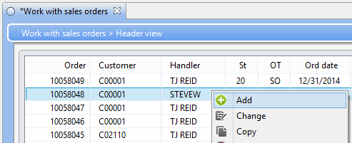From the “Work with sales orders” screen click and select Add.

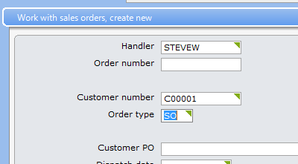Enter the client making the request and the order type.

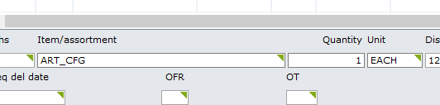Enter the item, quantity, and unit press enter. There will be a warning that you can ignore press enter again.

### Generate BOM/BOR

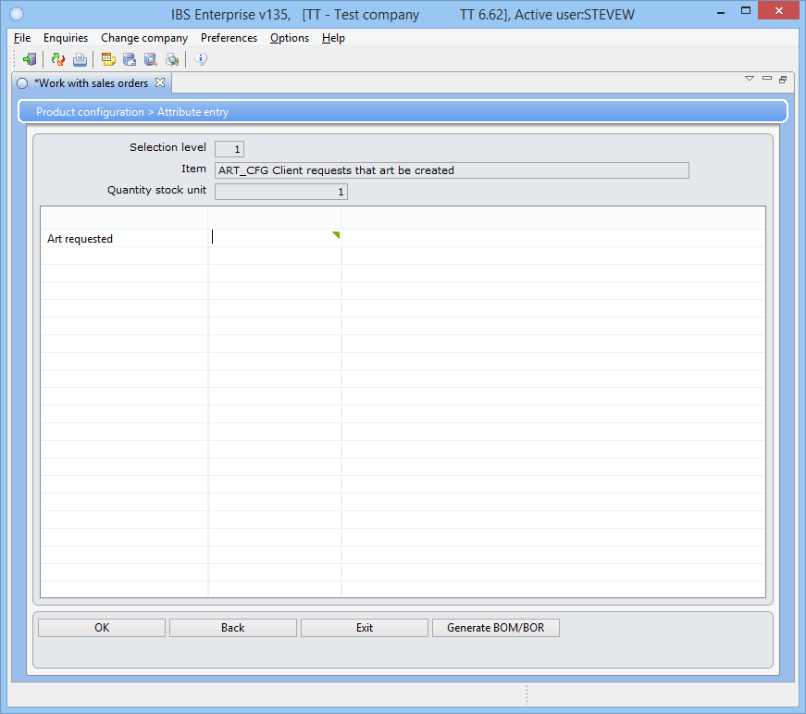

Once you have made it to this screen press the “Generate BOM/BOR” button.

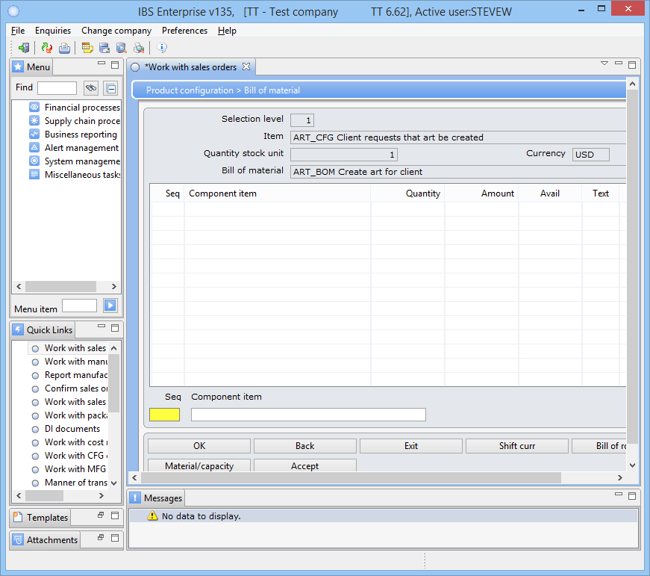There is no BOM data to display so ignore the message. If you want to give the Art department instructions then press the “Bill of Routing” button.

### BOR

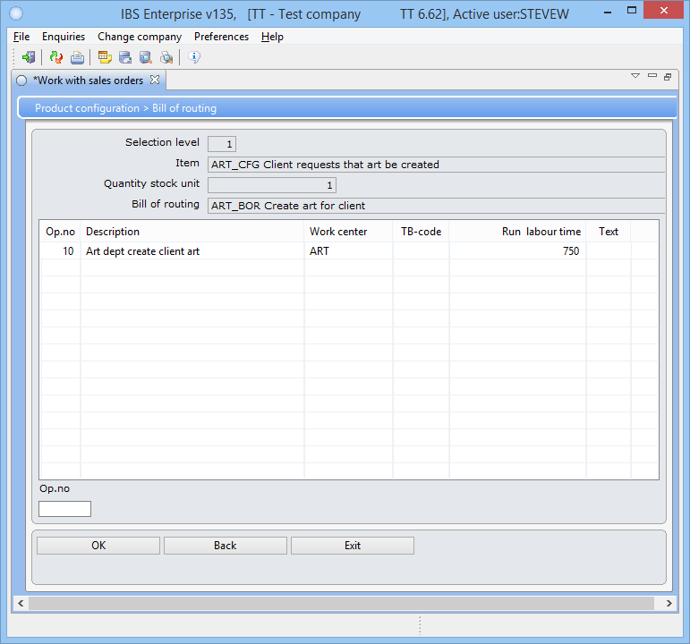

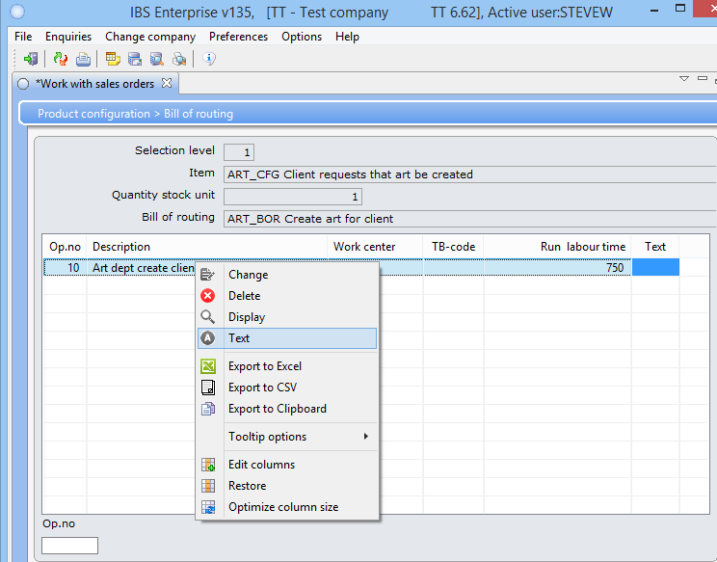Right click on “Op_no” 10 and select “Text”.

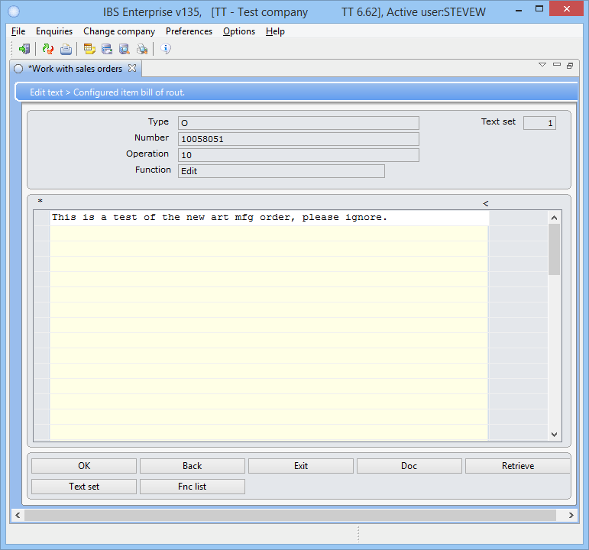

Enter the detailed instructions for the Art department worker, this will appear on the “Manufacturing order operation report”. Go back to the “Bill of material” screen and press Accept.

### Finish the order

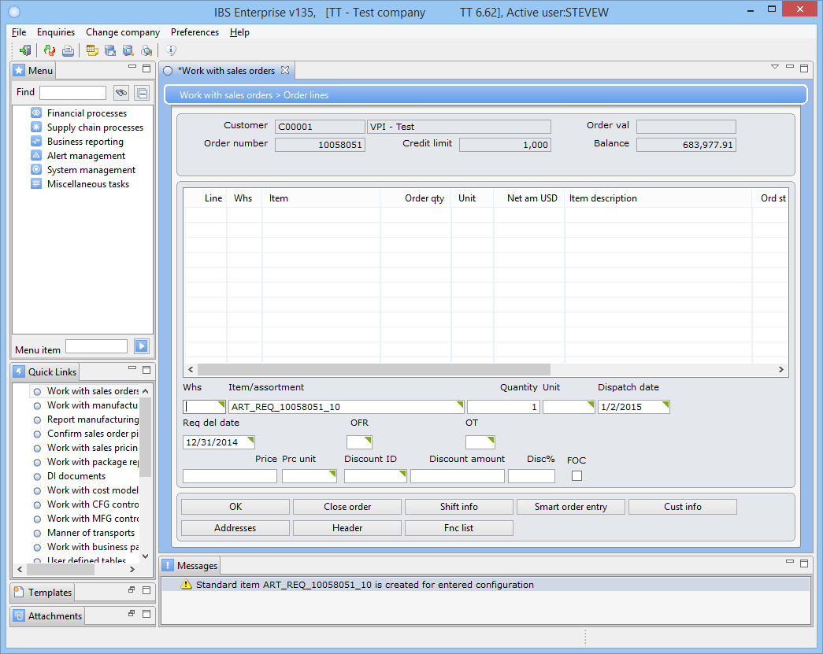

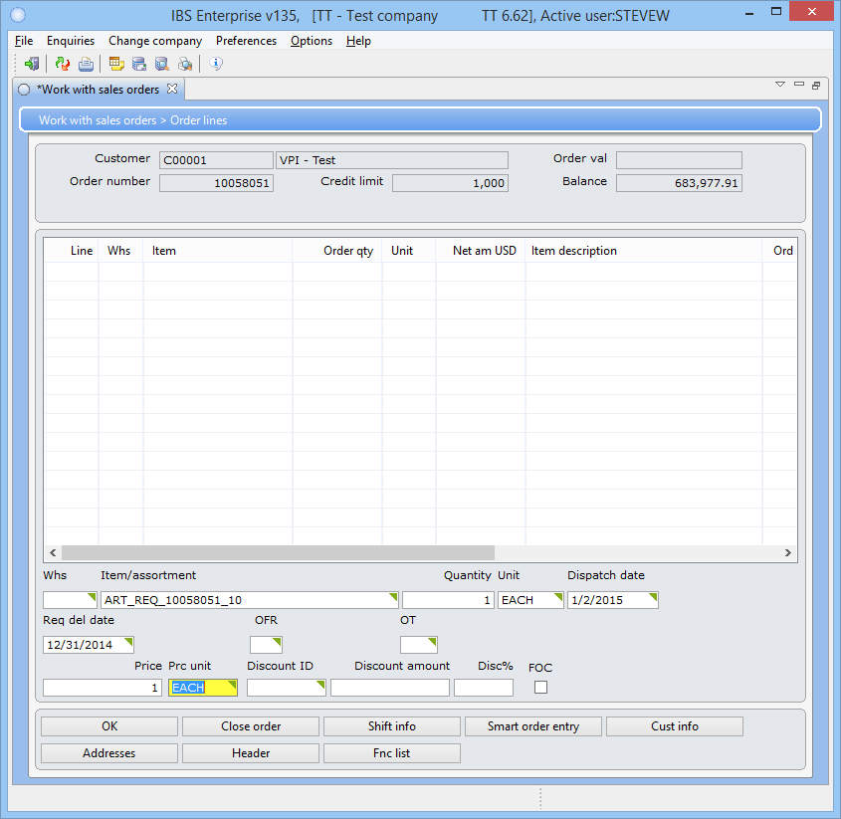Enter a price of 1 and a unit of each, press enter.

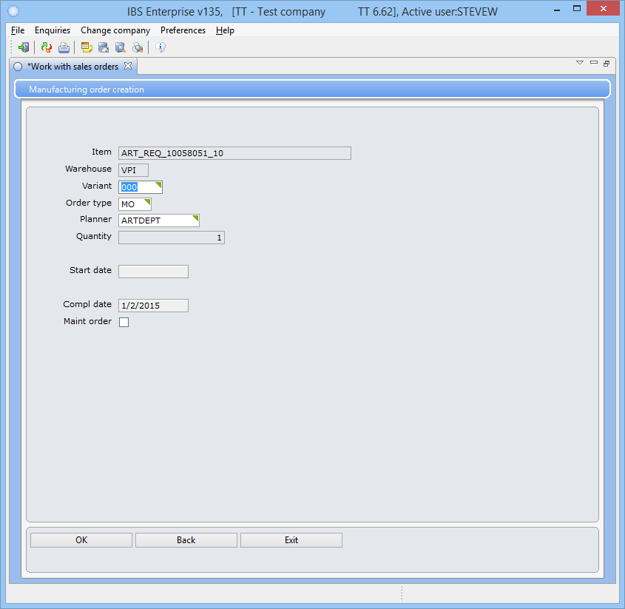Press enter.

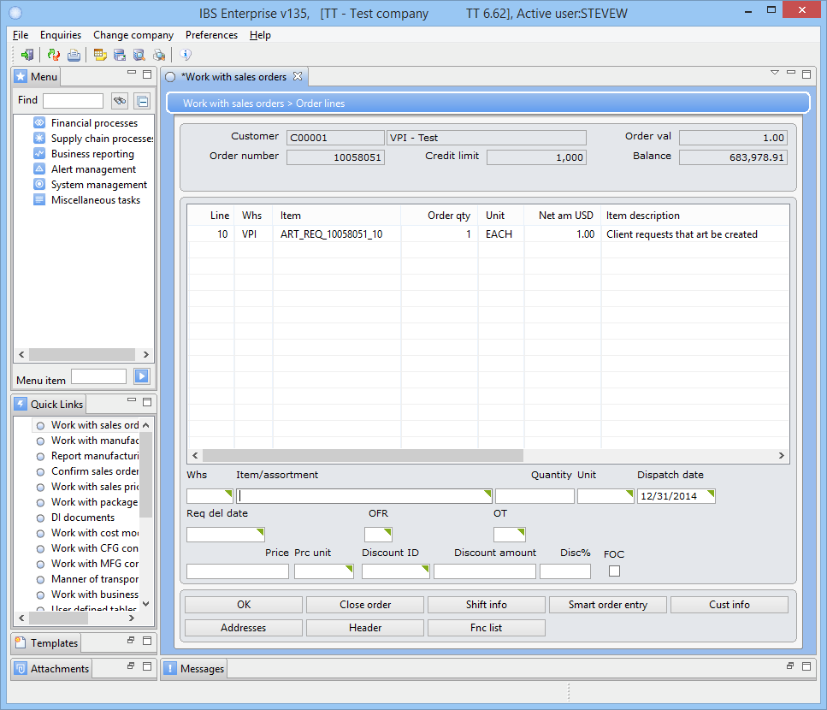

At this point you can go into the line and add the design name so that it shows in Planner View.

## MFG report

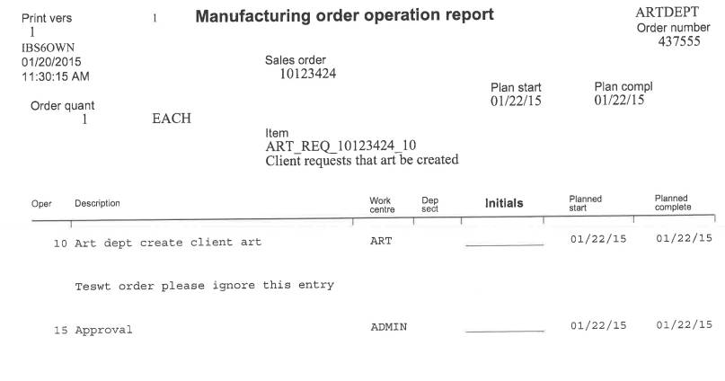

The order with your instructions will print on the Art department’s printer.

## Approve

Your order has been created. You will have to approve the order once the work has been completed. You will need to enter “Approved quantity” of 1, check the “Operation complete” box, enter “TS” in the “Zone”, Employee, and “TRANSIT” in the “Location” field. This information is needed in order for the pick list to be printed and the order to continue to flow through the system.

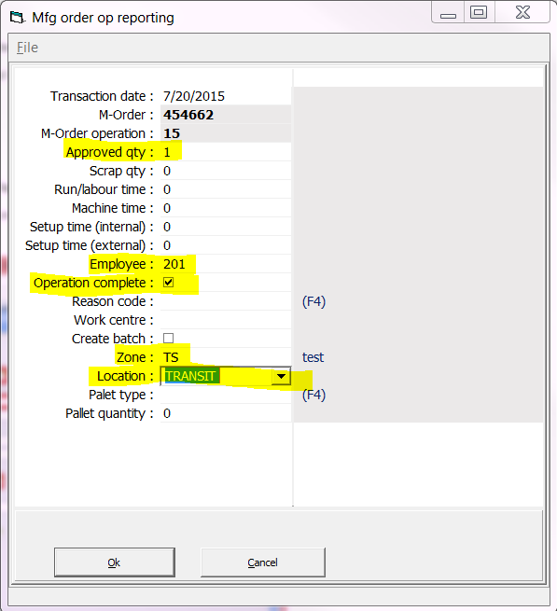

Approving the order using PlannerView.

## Pick list

Then at this point the pick list can be printed.

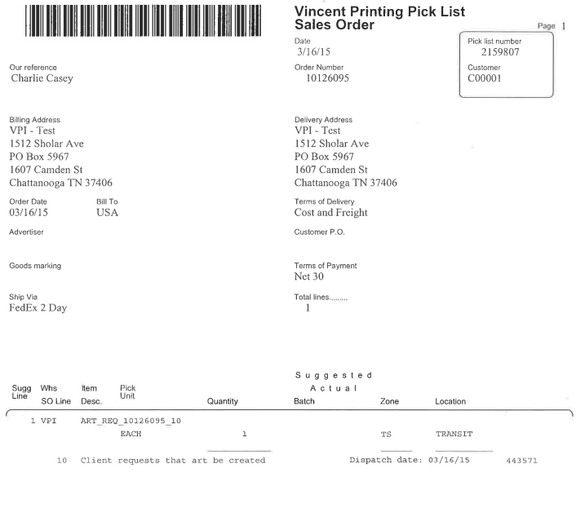

At this point you follow the same steps for pick list handling as you would any order.